**CSE461 LAB REPORT 05**

**Controlling of DC Motors using MPU-92/65- a 9-axis motion**

**processing unit**

**Prepared By:**

**GROUP 06**

| STUDENT NAME: STUDENT ID |
| --- |
| Fahim Morshed : 20201133 |
| Sadat Noor Shibly : 21101160 |
| Shakil Islam Shanto : 20101318 |
| Kamran Hassan Shomrat : 21101010 |
| Mollah Md Saif : 20101416 |

**Name of the experiment:**

Controlling of DC Motors using MPU-92/65- a 9-axis motion

processing unit

**Objective:**

This Lab is designed to provide the basic idea to control a DC motor using the MPU-92/65. By moving the sensor in an upward or downward direction, the direction of the motors will be changed..How to control a DC motor using l298N Motor driver

**Required Equipment:**

● Raspberry Pi

● MPU 92/65 IMU

● DC Motor (1 piece)

● Motor Driver L298N

● Battery 3.7V (2 piece)

● Battery Case (1)

● Jumper Wire

● Breadboard

**Experimental Setup**

**Picture of the Circuit:**

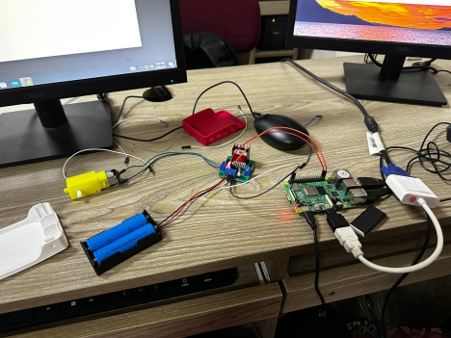

**Explanation:** we used raspberry pi , motor driver , motor and two batteries connected together in a case and we connected the red wire of battery is connected to the vcc of the motor driver and the ground of raspberry pi and the black wire of the battery is connected to the ground of motor driver then we connected the motor two wires into motor driver in outA and outB of motor driver and we connected gpio 20 and gpio21 to input a and input b of motor driver we also connected the 5 v of raspberry to 5v of motor driver

**Code**

**import RPi.GPIO as GPIO**

**from time import sleep**

**in1 = 20**

**in2 = 21**

**GPIO.setmode(GPIO.BCM)**

**GPIO.setup(in1,GPIO.OUT)**

**GPIO.setup(in2,GPIO.OUT)**

**GPIO.output(in1,GPIO.LOW)**

**GPIO.output(in2,GPIO.LOW)**

**while(True):**

**GPIO.output(in1,GPIO.LOW)**

**GPIO.output(in2,GPIO.HIGH)**

**sleep(2)**

**GPIO.output(in1,GPIO.HIGH)**

**GPIO.output(in2,GPIO.LOW)**

**sleep(2)**

**Results:**

After the experiment is finished, we will be able to use a Raspberry Pi and a motor driver to control the way that a DC motor rotates. The position of the motor's rotation can be changed by adjusting the state of the GPIO pins that are attached to the motor driver. Using a Raspberry Pi and a motor driver, this setup is a flexible and adaptable method to manage the rotation of a DC motor, with the ability to change the speed and direction of the motor rotation through software.

**Discussions:**

In conclusion, the system used to regulate a DC motor's rotation using a motor driver and a Raspberry Pi is a cheap and adaptable option for a variety of uses. Instead of connecting the motor directly to the Raspberry Pi, you can operate it more easily and securely by using a motor driver. Greater control and automation are made possible by the Raspberry Pi, which offers a simple method to easily control the direction and speed of the motor through software.The configuration also makes it simple to integrate additional sensors and gadgets, like limit switches or encoders, to improve the motor's control and input.moreover,The Python programming language and libraries like RPi.GPIO also make it simpler to create and change the motor control code.With the ability to change the direction and speed of the motor using software, the system for controlling the rotation of a DC motor using a motor driver and a Raspberry Pi offers an adaptable and individualized solution for motor control. When building up this system, it's crucial to make the right component choices and take the appropriate safety measures.